Car finder Web Portal

**Team members**

John Michael Hayde: [jhayde@clemson.edu](mailto:jhayde@clemson.edu)

**Description of Web Portal**

The Car Finder web portal is going to be designed for users to easily search for available cars based on a variety of characteristics, such as: price, make, model, year, color, and mileage. The user will be able to create an account or login if they already have an account. They will be able to use the system to search for cars based on their specified characteristics. Users will also be able to view/edit their personal information and log out when they are done using the system. There will also be an admin login where an administrator can add or remove cars from the database, as well as remove users.

**Data Generation Plan**

To gather the data for my database, I plan on writing a script that will make random Car entries based on lists of all the vehicle attributes (price, model, make, year, etc.). I will generate those lists by hand, from researching. Lists of car companies and listing out char characteristics. I will have the script write this data to a text file, where I will then be able to use MySQL statements to import the data into the database. By using a text file, I will be able to generate more data and use the same MySQL script to upload additional data to the database.

**Assumptions of Data Being Modeled**

The assumptions for the database are as follows:

* Each user will only have 1 account, they will not try to make another account when they already have one
* Each user has a distinct username
* Each car will have a unique VIN, so there cannot be duplicate vehicles
* Certain vehicle attributes, such as make, model, and color, can be shared over any number of vehicles.

**ER Diagram of Database Design**

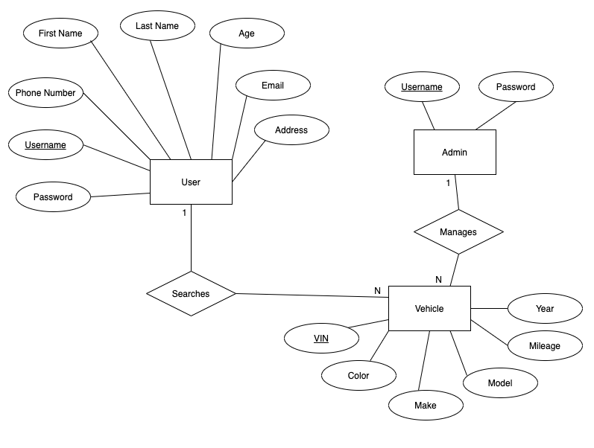

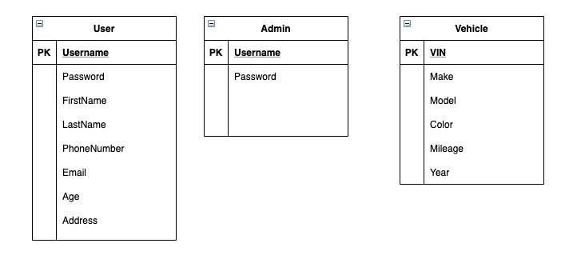**Database Design Schema**

**Description of Web Portal Interface**

The web portal will be broken up into 3 main interfaces: login, database search, and account management.

The main page will allow the user to select one of 3 options: returning user login, new user login, or admin login (admin login may be changed to directly accessing a website/admin page to login). When the user selects one of these options, they will be routed to the specified page. Returning user login will simply allow a user to enter their username and password, verify both fields are filled out, and verify this information with the database. If the information matches a logged account, they will be allowed into the system. The new user login page prompts the user for a host of information, such as: first name, last name, email, phone number. It also prompts them to make a password. The website will not let the user in until all fields are filled out, and the 2 passwords match. The admin login will allow admin users to log in and will route them to the admin portal.

Once a normal user is logged, they will be able to search the database for cars based on any characteristic they select. The search will display results on the webpage. The user will be able to perform as many searches as they would like. The information will be displayed in a table, each row containing information about a specific vehicle.

The user will also be able to view and edit their account information. They will access this by clicking on a tab specified for viewing their account information. They can change any field they want. If they chose to change the username or password, this will have to be changed in the database as well.

The admin portal will allow them to add and remove vehicles to the database, as well as removing users from the system.